**Lab # 09**

**OBJECT**

***Configure DNS and DHCP Server***

**TOPOLOGY:**

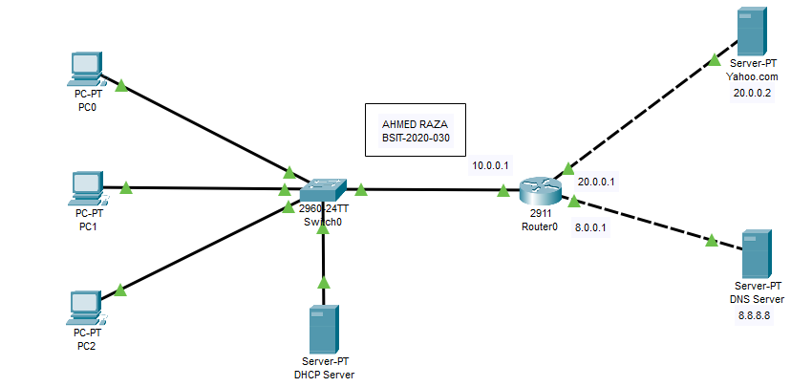

**LAB TASK:**

**Part 1: Design the above Topology in Packet Tracer using appropriate IPs**

**Part 2: Set up dedicated DHCP-server for dynamically assigning IP addresses**

**Part 3: Set up DNS-server for forwarding a request to the Web Server**

**Part 4: Set up Router as a DHCP-server for dynamically assigning IP**

**addresses**

**Part 1: Design the above Topology in Packet Tracer using appropriate IPs**

a. Configure IP addressing on PC1,2,3, DNS server, Yahoo Server.

PC 0:

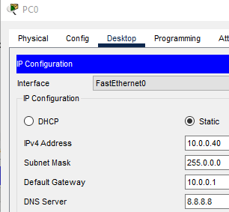

PC 1:

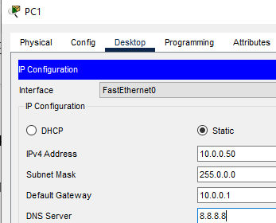

PC2:

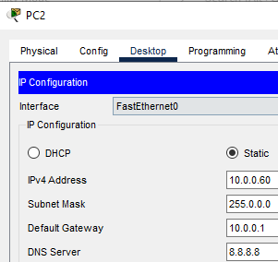

DNS SERVER:

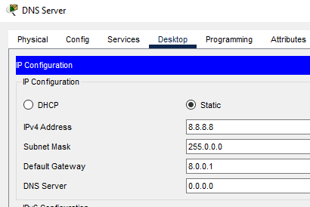

YAHOO SERVER:

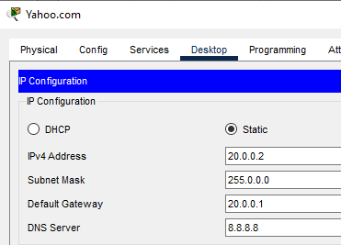

b. Configure the hostname as (Your name)-Router.

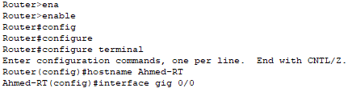

c. Configure IP addressing on Router and enable the interface.

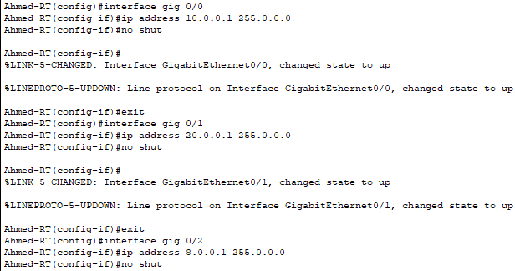

d. Save the configuration to NVRAM.

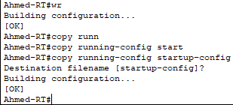

**Part 2: Set up dedicated DHCP-server for dynamically assigning IP addresses**

a. Attach the screenshot of the DHCP Server configuration. Use the DHCP pool

name as your own name.

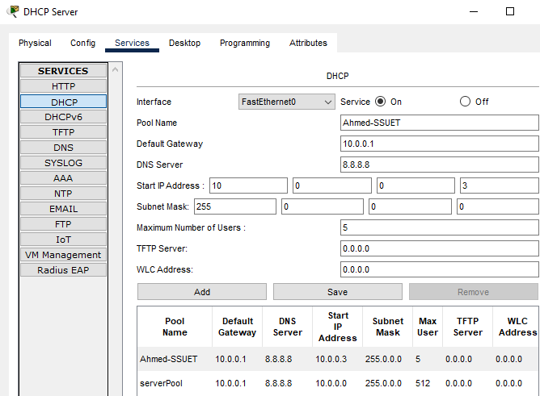

b. Attach the Screenshot of the PC 1, 2 showing that its obtaining the IP address dynamically.

PC0:

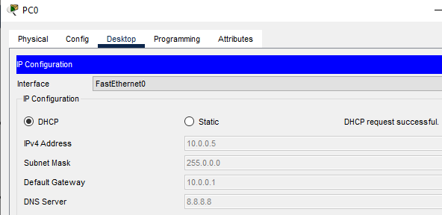

PC1:

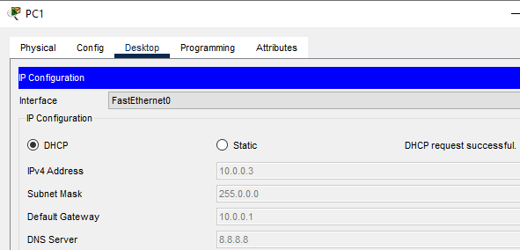

**Part 3: Set up DNS-server for forwarding a request to the Web Server**

1. Attach the screenshot of the DNS Server configuration.

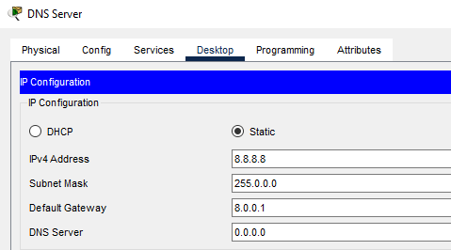

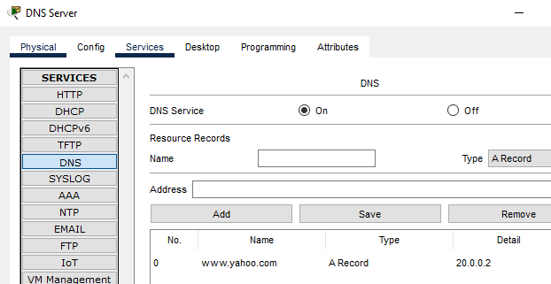

b. Attach the screenshot of the web browser of PC 1, 2 showing that its obtaining the

hostname Yahoo.com.

PC0:

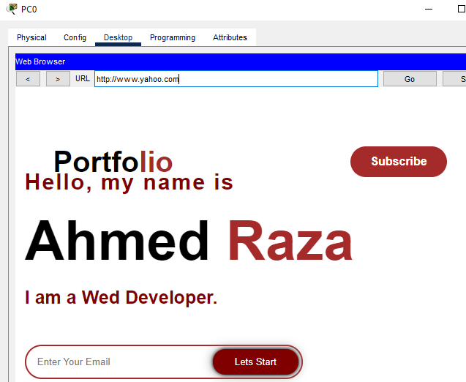

PC1:

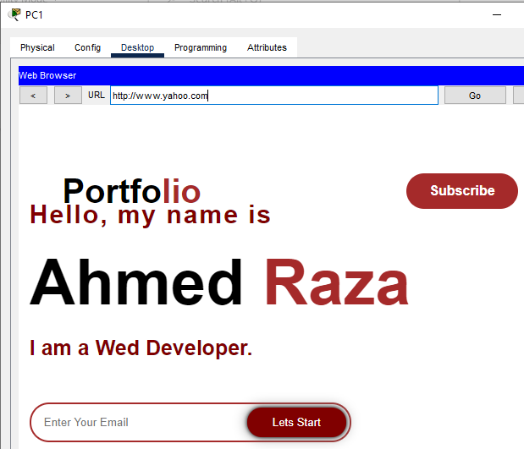

**Part 4: Set up Router as a DHCP-server for dynamically assigning IP**

**Addresses**

a. Attach the screenshot of the Routers DHCP Server configuration. Use the DHCP

pool name as SSUET.

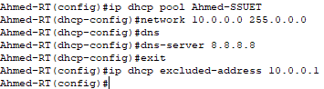

**Answer the following questions regarding the lab you have performed:**

1. Which command will be use to verify DHCP bindings on Router?

A). Show ip dhcp binding.

2. How does a DHCP server dynamically assign IP address to host?

A). Addresses are permanently assigned so that the host uses the same address all the time. Addresses are allocated after a negotiation between the user and the host to determine the length of the user.

3. Which protocol and port number does DNS use for direct queries?

A). DNS uses the User Datagram Protocol (UDP) on **port 53** to serve DNS queries. UDP is preferred because it is fast and has low overhead. A DNS query is a single UDP request from the DNS client followed by a single UDP reply from the server.